# Changes Hub @ AirTable

# ****Description****

Changes Hub is a table on AirTable that aggregates all Change information from various sources within eBay.

This is an effort to provide a one-stop database to store Change information.

Changes Hub's timeline view also provides a clear and concise user interface that can be imbedded in [Control Center Metadata - Change page](https://adsshepherd.muse.qa.ebay.com/metadata/changes?end=1678690800&start=1675062000&type=Launch&type=Project&view=plannedEP).

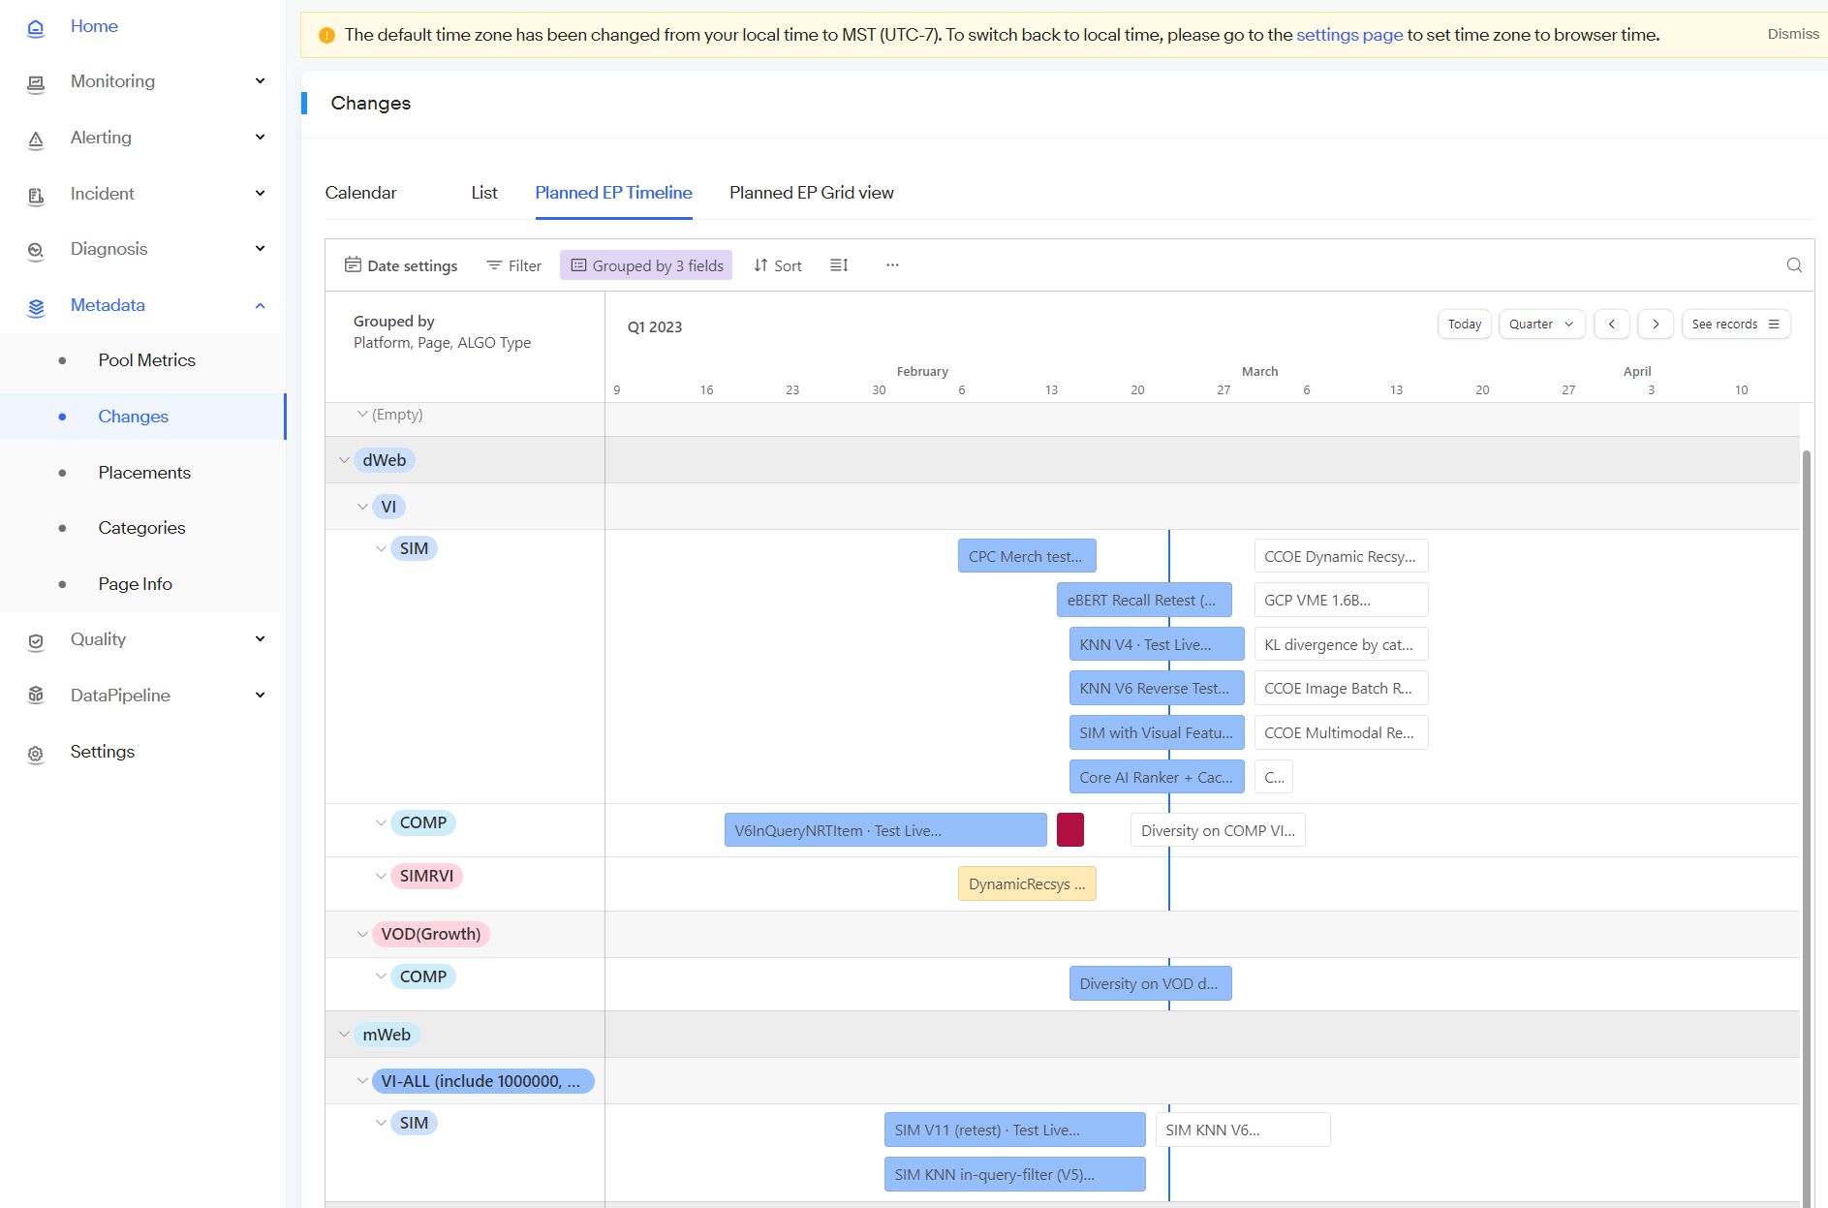

When alerts are fired, on-call personnel can swiftly inspect the recent changes deployed and triage the root cause of alerts.

Users can find information about historical changes for all the types below:

1. Code Roll
2. Config
3. Milestone (Project)
4. EP
5. DSS
6. Rheos
7. Launched changes

Unlaunched but planned EPs information are also available on Control Hub.

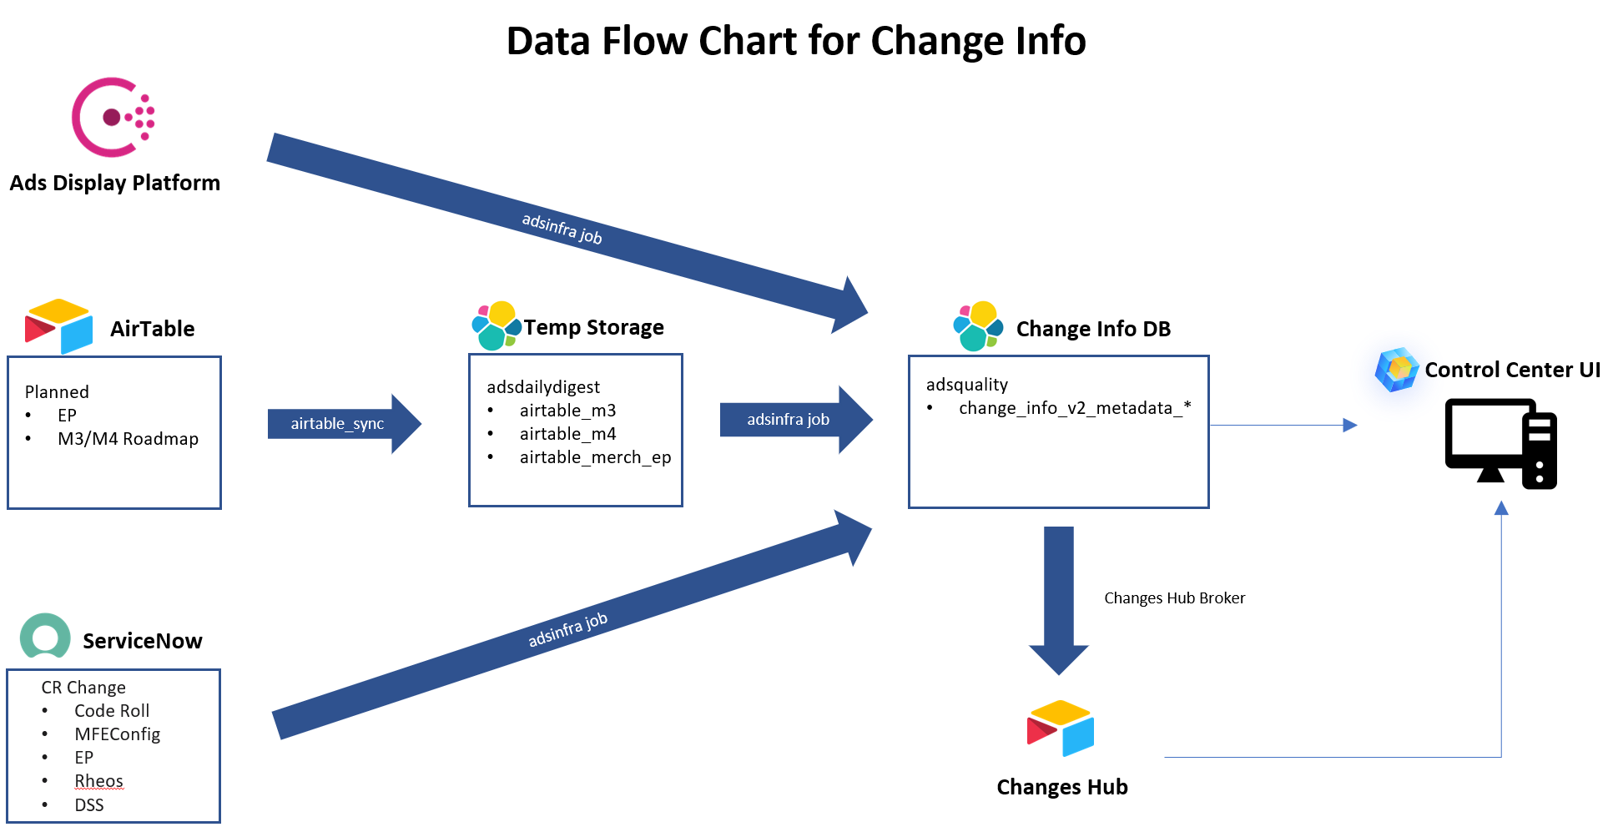

# ****Related link****

Changes Hub @ AirTable: <https://airtable.com/appIblILjltrNMOgj/>

Control Center: <https://adsshepherd.muse.vip.ebay.com/>

Adsdailydigest ES: <https://esadsdailydigest-kibanalvs.vip.ebay.com/>

Adsquality ES: [https://esadsquality-kibanaslc.vip.ebay.com](https://esadsquality-kibanaslc.vip.ebay.com/)